•Firewall Configuration

Centos use firewall to blocking ssh remote access

1. Open the terminal

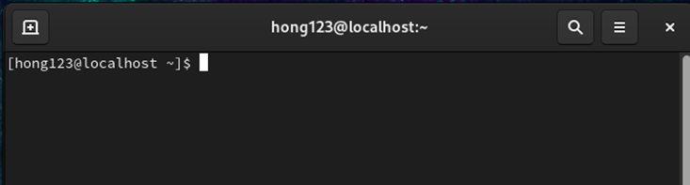

2. check the firewall status

First write the command “sudo systemctl status firewalld” in the terminal to see the firewall status.you can see the firewall status is inactive(dead).

3. Start the firewall

If the firewall status is not the active(running) you need to write the command “sudo systemctl start firewalld” to active the firewall.

If the firewall is active(running) you can pass this step.

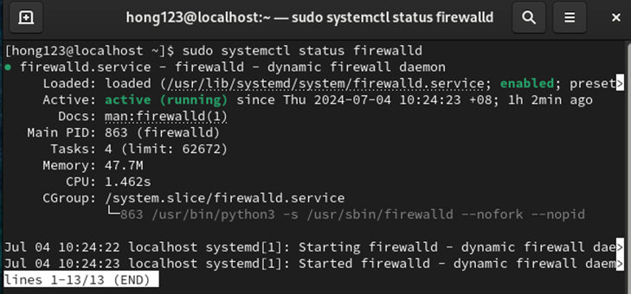

4. Block SSH Access

Write the command “sudo firewall-cmd --zone=public --remove-service=ssh –permanent” to block the ssh remote.

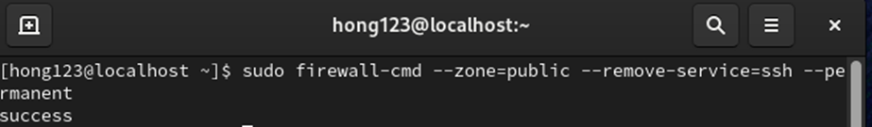

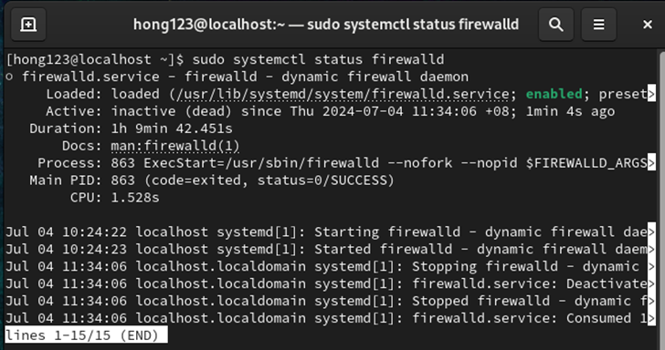After you need to write the command “sudo firewall-cmd –reload “ to refresh the firewall.

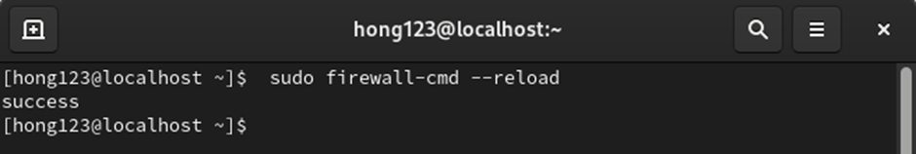

You can test the ssh remote is blocking success or not.

Open the ssh remote software for example PuTTY

Write the IP address entered the system

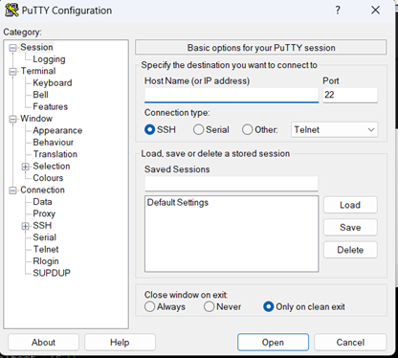

You can see the ssh remote is no reaction

That mean you success use the firewall to block the ssh access.

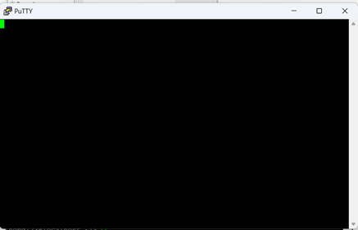

5. Unblock the SSH Service

sudo firewall-cmd --zone=public --add-service=ssh –permanent

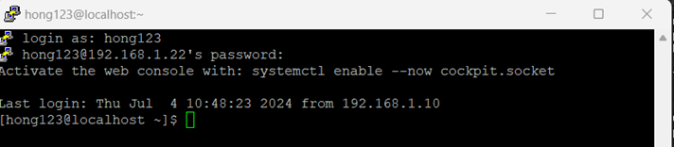

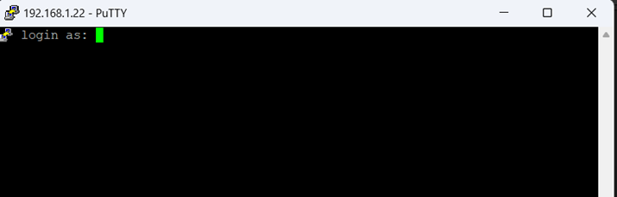

example 2

firewall block the ip

1.check the window host and Ubuntu VM can verify the network configuration.

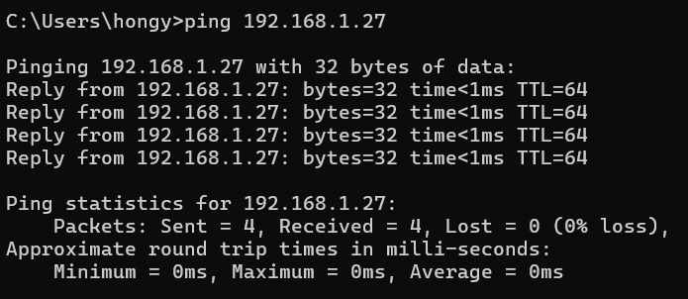

The Windows host successfully sends a ping request to the Ubuntu VM to verify the network configuration.

2.add the new rule to block the ip address

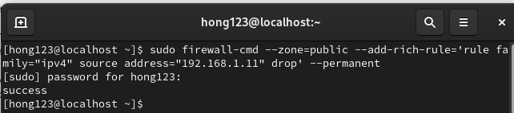

first you need to add the new rule to block the ip use the command

“sudo firewall-cmd –zone=public –add-rich-rule=’rule family=”ipv4”’source address=”192.168.1.11”drop ‘ –permanent”

3.refresh the firewall 

refresh the firewall rule use the command “sudo firewall-cmd –reload”

4.Verify whether the firewall rule is effectively blocking the IP address

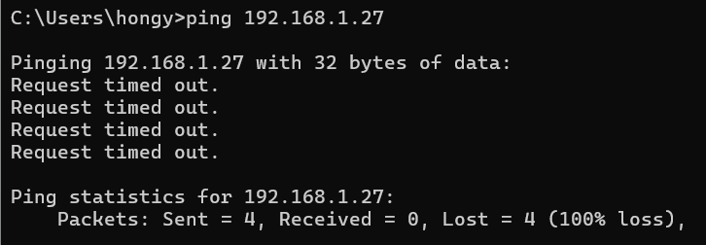

open the window cmd to verify the network configuration.you can see the request timed out means the firewall is successful to block the ip address.

5.Unblock the IP Address



sudo firewall-cmd –zone=public –remove-rich-rule=’rule family=”ipv4”’source address=”192.168.1.11”drop ‘ –permanent

sudo firewall-cmd –reload

Use the above command this will effectively remove the rule that blocks the IP address and apply the changes.

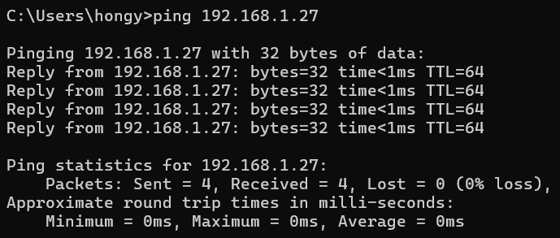

re-test connectivity to ensure the IP address is unblocked.

Reference

<https://developer.moduyun.com/article/61661c33-7df0-11ee-b225-6c92bf60bba4.html>

<https://www.server-world.info/en/note?os=CentOS_Stream_9&p=firewalld&f=1>

<https://pimylifeup.com/ubuntu-ping/>